**Personal Project**

**Criterion A: Planning**

Learning Goal: To learn to become a better tutor through research and conducting workshops

Global Context: Identities and Relationships

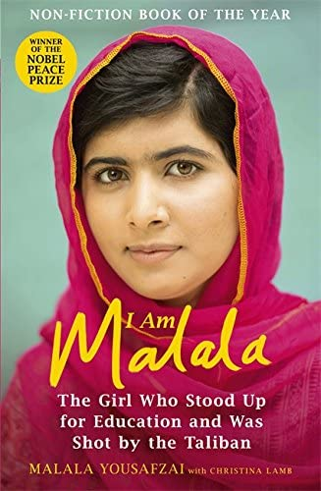**How I chose my learning goal:**

“One child, one teacher, one book, one pen can change the world."― Malala Yousafzai. This quote inspired my interest in teaching and tutoring. In grade 5, we read the autobiographical book, “I Am Malala”. It follows the journey of Malala, who was shot in the head by the Taliban because she continued to go to school when she wasn't allowed to, and campaigning for girls’ education. She is now the youngest Nobel Peace Prize laureate and continues to advocate for education rights. While reading this book, I thought about how many kids around the world had to drop out of school and couldn't get a proper education, and how I should be immensely grateful that I am receiving an education. This also made me fall in love with the vocation of teaching, and how one teacher can have such a significant impact on a student, and her life. I wanted to inspire other people as well because the more teachers there are, the more minds can be shaped, and the brighter our future will be.

Image 1: Book Cover

I wanted to share this knowledge in a modern method, so I decided to produce a podcast show and incorporate the lessons I have learned in the past year that I have been tutoring. The podcast will be designed as short episodes that give teenagers the building blocks for how to tutor, and how they can become professional teachers if they choose to do so in their careers.

Passion drove me to this topic, as tutoring was one of my favorite things to do in my spare time. I loved it so much because I felt a sense of importance, responsibility, and ownership which I had never felt before. It empowered me. Growing up, I never stood up for myself, or expressed my thoughts because I was afraid that people would judge me or make fun of what I had to say. I felt like my ideas added no value to what was being discussed, and that they were worthless. But when I tutored, my students wanted to listen to me and showed interest in what I was saying. It made me more confident. I proved to myself that my thoughts are important and respected, and that I shouldn’t be afraid to express them.

Furthermore, while tutoring, I felt like a winner. Maybe it was beginner’s luck. Maybe it was the topics I was teaching, which were easy since I started by tutoring younger grades, but the taste of success was sweet. This was very important to me as I was fearful of failure. I saw failure as a sign of incompetence, and always avoided anything that might lead me to a contrary outcome. In retrospect, while tutoring, I stumbled many times but the lesson it taught me was that it was okay to fall. It is more important to get up every single time and start again. I learned that correcting my mistake, was not a sign of weakness; it was an opportunity to grow. By realizing that I was able to handle my failures while tutoring, I decided to take risks and challenges in my school life as well. Rather than giving up, I decided to try until I found success.

I also chose tutoring as the topic of my learning goal because I enjoy being surrounded by children. They have a unique, creative, and possibly a rose-tinted view of the world. Their enthusiasm and optimism provided me with hope on the days when I was not feeling my best. I felt free to be my own, true self in front of children, as they would not judge me for what I wore, how I looked, or what I liked. They would laugh with me instead of at me. This is rare to find today among adolescents and grown-ups.

What inspired me deeply is also that my mom is a teacher. Watching her while growing up made me want to emulate her. Her classes were entertaining and educational, helping students grasp the topic fully. Any topic that she’s taught me, I have clearly understood. By the end of this project, I wanted to be able to experience that competence, and provide other teenagers with steps to discover their own passion for teaching. Seeing how significant an impact she had on her students, made me want to adopt tutoring to make someone’s life better. A teacher can have an indelible and transformational impact on a student’s life and future. I want to inspire other individuals to consider teaching and tutoring as a calling. This inspired my learning goal, which is to learn to become a better teacher through research and conducting workshops. While I was brainstorming ideas for the learning goal, I created a mindmap (refer to image 2) which outlined 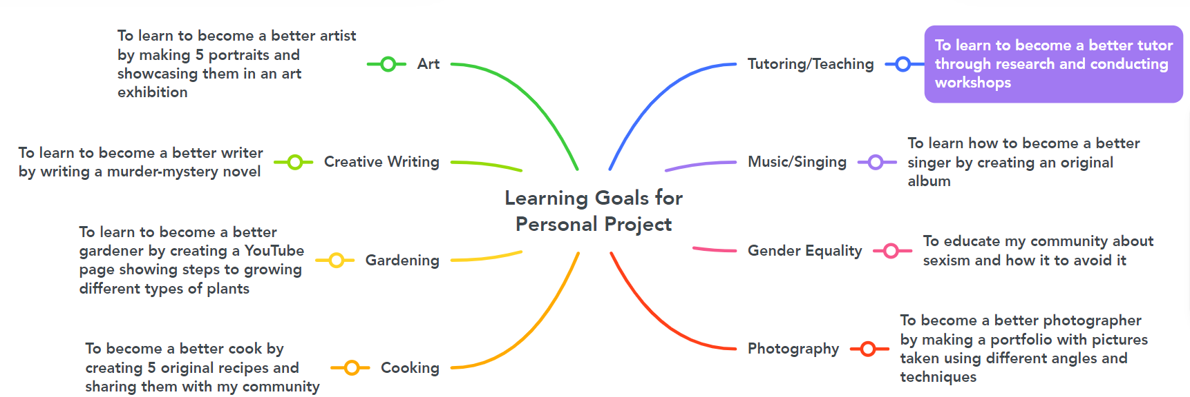my interests, and then possible learning goals for each of those interests.

Image 2: Potential learning goals based on my interests

I narrowed it down to the learning goal related to tutoring/teaching (which is highlighted in purple) as it was the topic that I was the most passionate about. I also had prior learning and subject-specific knowledge related to my learning goal (refer to table 1 below). I was confident that I could expand and improve throughout the project, and that I had a strong base to achieve my learning goal.

|  |  |
| --- | --- |
| **Prior Learning** | **Subject-Specific Knowledge** |
| **Interviewing an expert**: I have conducted multiple interviews in the past to collect expert feedback on my product or report. Hence, I feel confident with conducting interviews of parents to gain feedback about the workshops. | **Business**: In many business revision lessons, we are encouraged to create activities to assess our peers on the topic. Because of this, I was able to learn about educational activities that I could use in my workshops, such as, Kahoot, Quizzes, Word Searches, and topic-related games. |
| **Storytelling**: When I was younger, I used to watch BrainPOP videos, in which the main character Tim and Moby would narrate stories and apply subject knowledge to those stories. It would help students understand that topic in a fun and engaging way, I was inspired to use storytelling in my workshops to make students understand concepts in an easy manner, and in a way that they wouldn't forget easily. | **Digital Design**: In DD, we work with many applications such as Canva, Scratch, Adobe Premiere Pro, and Sublime Text. A lot of the time, I would come across a technical error while working on these applications, and to solve that I would use collaboration. I would collaborate with my teacher and my peers and ask them to help me identify and solve errors. This skill is useful as I will have to collaborate when I am teaching the workshops. |
| **Survey**: I have created and collected many responses to surveys. It is an essential part of collecting evidence in the MYP curriculum. I have also created surveys for personal use, such as when I’m trying to select a board game for me and my family to play and ask them for their preferences. Since I have created surveys on a large variety of topics, I am confident about creating them to gain feedback for my workshops. | **History**: In History, we evaluate many sources to find out which one is credible, and which one is biased. Through this process, we can come to a reasonable conclusion based on the unbiased sources to find out exactly what happened during a historical event. Similarly, for my lesson plans, I will be evaluating sources through the OPVL method to ensure that they are trustworthy and dependable. |

**Product Goal:** Apodcast that will give teenagers basic information about tutoring, and share with them steps about how to start tutoring

Table 1: Prior learning and subject-specific knowledge related to the learning goal

**How I chose my product goal:** First, I wanted to learn hands-on via experimenting and working with different types of formats. Once I had gathered the basic know-how, I wanted to share my knowledge in a contemporary way, based on the target audience. Therefore, I decided to write and produce a podcast that would bring together insights I had gathered by tutoring students in Math and English for about a year. The product I wanted to create was a podcast series that would be tailored to a teenage audience, and uploaded to secure streaming platforms, such as, Spotify and Apple Podcasts. It would be designed as short, engaging episodes, scripted, recorded, edited, and marketed towards teenagers to give them the first steps to tutoring, and answers to their most common questions. Podcasts can be heard on the go – while completing a chore or commuting to school – hence, they are perfect for the target audience. With each episode, templates and resources would be provided in the description box, so that they can use these to teach their students. As I was brainstorming different product goals, I made a table (refer to table 2) that listed 3 different product goals related to my learning goal, their advantages, and their disadvantages. This way, I was able to weigh the pros and the cons of each product goal, and I went with creating a podcast 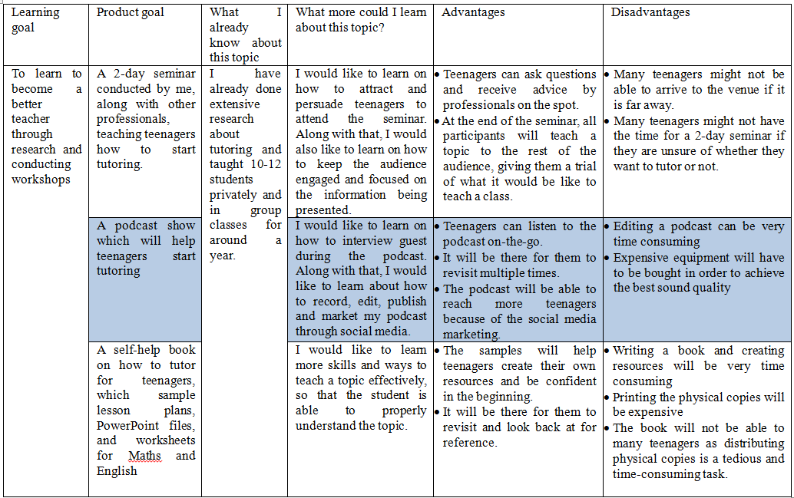show (highlighted in blue) because I had solutions for the disadvantages.

Table 2: Possible product goals

To resolve the disadvantages mentioned in table 2, I will learn how to edit using beginner-friendly software that isn't very complicated to understand, like iMovie or Riverside FM. Additionally, since my episodes are only going to be 5-6 minutes long, there will not be much content to edit. As for the equipment, I have recorded a trial episode with the microphone of a pair of wired headphones, and the quality is excellent. So, I will not have to invest in professional equipment. As I was able to find solutions for both my disadvantages, and because I have prior learning and subject-specific learning (refer to table 1) I think creating a podcast would be the best product goal for this learning goal. I aim to help peers figure out how to explore tutoring and be good at it. Possibly some of them, encouraged by this experience, might even take up teaching as a profession. My goal is to solve their challenges by sharing simple steps that can be adopted. I also wanted to bring in experts who would share insights from their several years of practice and hence accelerate learning with pragmatic suggestions.

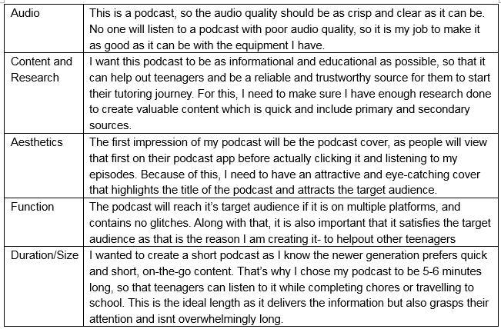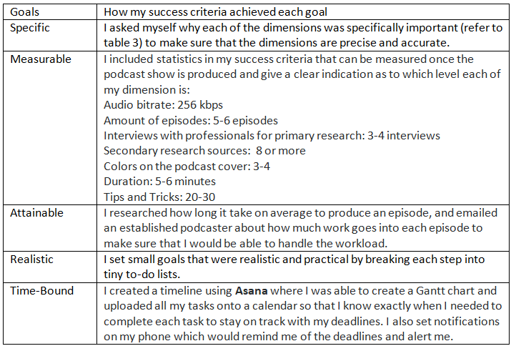**Success Criteria:** I decided to create my success criteria on the five dimensions: Audio, Content and Research, Aesthetics, Function, and Duration/Size. Table 3 explains why I chose each dimension. I have made sure my success criteria comply with the SMART goals framework (refer to table 4).

Table 4: Evaluating my success criteria based on the SMART framework

Table 3: Why I chose these dimensions

To create a challenging yet achievable measure, I analyzed examples of success criteria and consulted my supervisor. I created metrics (refer to table 5) that showed detailed product requirements for each level.

These success criterias are important to me because I want to make a product teenagers can use in their daily lives; a product that is informational and useful, backed with research and rich in content. If the podcast doesn't help any of my listeners, they will move on and look for another way to get the same information. Some of them might get disheartened when they discover that the process is complex or even overwhelming. But with my podcast, these difficulties can be avoided, and teenagers can start tutoring without any hesitation, and with simple methods.

Table 5: Success Criteria

|  |  |  |  |  |  |
| --- | --- | --- | --- | --- | --- |
| **Design Specification** | **Audio**:  What bitrate will the audio be like? How to record clear audio and edit it to reduce background noise? | **Content & Research:**  How many workshops should I conduct to provide accurate information about students in class? How should I make the content credible and engaging for the listeners? | **Aesthetics:**  What elements of a podcast cover would catch the attention of a teenager? | **Function:**  What is the purpose of the podcast? Which streaming platforms would be best to reach the target audience (teenagers)? How many episodes should the podcast have? Which tips and tricks would be useful for beginners? | **Duration:**  How long should each episode be so that the target audience (teenagers) is attentive and focused on the content? |
| **Limited** | **i. poor audio** (32 KBPS or lower) achieved by **no** equipment  scarcely audible throughout the podcast  ii. **inadequate** background music (detectibly loud or soft)  iii. audio and background music **consistently** fluctuating throughout the podcast | i. episodes are **very hard** to understand and **extremely disorganized**.  ii. Content is **extremely hard** to understand, is not at all backed up by scientific facts, and no interviews are conducted.  iii. **Poor** research was conducted.  Primary Research: **No workshops** were held to observe students  Secondary Research: None **or 1-3 source**s are analyzed including YouTube videos, Journals, Articles, Books and more | i. the podcast cover has **no** color and isn’t attractive or eye-catching **at all** | i. podcast is **not accessible/very difficult** to access to the audience.  ii. podcast **isn’t available** on any streaming platforms  iii. the podcast **contains virus/harmful materials**  iv**.** thepodcast is found on **unreliable/inappropriate streaming platforms**  v. the tips, tricks, and advice are **rarely**/not always practicable, relevant, or effective for teenagers  vi. podcast satisfies/helps **only 20%** or less of listeners  vii. **less** than **2** **episodes** with fewer than **5** **tips and tricks** in total. | i. podcast is **limited** in length; each episode is **less than 2 minutes** **long or more than 10 minutes long** |
| **3-4**  **Adequate** | **i. adequate audio** (64 KBPS) achieved by **some** equipment  ii. audible to a **partial** extent throughout the podcast  iii. **adequate** background music (detectibly loud or soft)  iv. audio and background music **majorly** fluctuate through the podcast | i. episodes are **somewhat categorized** but still confusing for teenagers to follow.  ii. Content is **somewhat easy** to understand, **isn’t completely** backed up by scientific facts, and no interviews are held with professionals.  iii. **Adequate** research was conducted.  Primary Research: **2-3 workshops** were held to observe students in real-life and come up with advice based on the student's behavior and response  Secondary Research: **4-6 sources** are analyzed including YouTube videos, Journals, Articles, Books, and more | i. the podcast is **somewhat** attractive and eye-catching and uses colors (1-2 colors) | i. podcast is **scarcely accessible** to the audience.  ii. podcast **is only available on 2 safe** streaming platforms  iii. the podcast **contains many glitches and technical errors (more than 4)**  iv. the tips, tricks, and advice are only sometimes practicable, relevant, or effective for teenagers  v. podcast satisfies/helps **only 40%** of listeners  vi. **less** than **4 episodes** with **less** than **10 tips and tricks** in total. | i. podcast is **adequate** in length; each episode **is more than 3 minutes long and less than 8 minutes** **long** |
| **5-6 Satisfactory** | **i. acceptable audio** (128 KBPS) achieved by **some** equipment  ii. audible to a **mediocre** extent throughout the podcast  iii. **good** background music (either a bit too loud or a bit too soft) to accompany the podcast  iv. audio and background music minorly fluctuates through the podcast | i. episodes are categorized but **could be simplified**.  ii. content is **somewhat easy** to understand and is **partially** backed up by scientific facts, and some (2-3) interviews are held with professionals.  iii. **Average** research was conducted.  Primary Research: **3-4 workshops** were held to observe students in real-life and come up with advice based on the student's behavior and response  Secondary Research: **6-7 sources** are analyzed including YouTube videos, Journals, Articles, Books, and more | i. the podcast cover is **hand-drawn/digitally illustrated** using **multiple artistic elements** (such as characters, 2-3 colors, and text) | i. podcast is **mostly accessible** to the audience.  ii. podcast is onlyavailable on **3 safe streaming** platforms  iii. the podcast **contains some glitches and technical errors (1-3)**  iv. the tips, tricks, and advice are practicable, relevant, or effective for teenagers the **majority of the time**  v. podcast satisfies/helps **only 60%** of listeners  vi. **4-5 episodes** **with less than 15 tips and tricks** in total. | i. podcast is **average**; each episode is around **4-7 minutes long**. |
| **8**  **Excellent** | **i. clear and crisp audio** (256 KBPS) achieved by a professional mic and recording set-up.  ii. audible to a **high** standard throughout the podcast  **iii. excellent** background music (-18dBs and -20dBs lower than the main commentary; not too high or too low) to accompany the commentary of the podcast | i. episodes are **efficiently** categorized and segregated  ii. content is **easy to understand**, backed up by scientific facts, and interviews (3-4) conducted with professionals.  iii. **extensive** research was conducted.  Primary Research: **4-5 workshops** were held to observe students in real-life and come up with advice based on the student's behavior and response  Secondary Research: **8 sources** are analyzed including YouTube videos, Journals, Articles, Books, and more | i. the podcast cover is **hand-drawn/digitally illustrated** using **all** artistic elements (such as characters, 3-4 colors, and text) | i. podcast is **always** accessible to the audience.  ii. podcast available on **all safe** streaming platforms (such as Spotify, Apple Podcasts, Google Podcasts, and Audible)  iii. the podcast **contains no glitches or technical errors**  iv. the tips, tricks, and advice are always practicable, relevant, and effective for teenagers  v. podcast satisfies/helps **80% or more** of listeners  vi. **5-6 episodes with 20-30 tips and tricks** in total. | i. podcast is **excellent** in length; each episode is around **5-6 minutes long**. |

**Action Plan:**

I decided to create a detailed action plan (refer to table 6) for each step I had to complete to accomplish my 5 main goals throughout this project, which were: learning goal, project goal, success criteria and action plan, learning sessions, and the podcast. I also mentioned the ATL skills used in each step, the success criteria dimension it was related to, if the task was completed on time, and if not, the rationale for it. This plan helped me keep track of the dates and allowed me to provide a reasonable explanation for the times I was late in meeting my deadline, allowing me to evaluate my time management skills.

|  |  |  |  |  |  |  |  |
| --- | --- | --- | --- | --- | --- | --- | --- |
| Expected Date | Task: | To-Do: | Success Criteria | ATL Skills | Reflection | New Date | Rationale |
| August 10 | Publishing the podcast and marketing it | * Publish the episode and share the link to social media apps such as WhatsApp, Instagram, and Snapchat | Function | Communication and transfer skills | Completed | On-time |  |
| August 11 | Planning the podcast | * Create a summary and script for episode #2, including at least 5-6 tips that were noted down before * Include primary and secondary research conducted before | Content and Research | Thinking skills such as critical thinking and creative thinking  Organization skills | Completed | August 12 | This script took a lot longer to make as there was a lot of research that was conducted for this episode and condensing that research took more time. |
| August 11 | Recording the podcast | * Record episode #2 and make sure it’s 20-25 minutes long * Interview a professional teacher | Audio, Duration | Critical thinking | Completed | On-time |  |

Table 6: Snippet of Action Plan